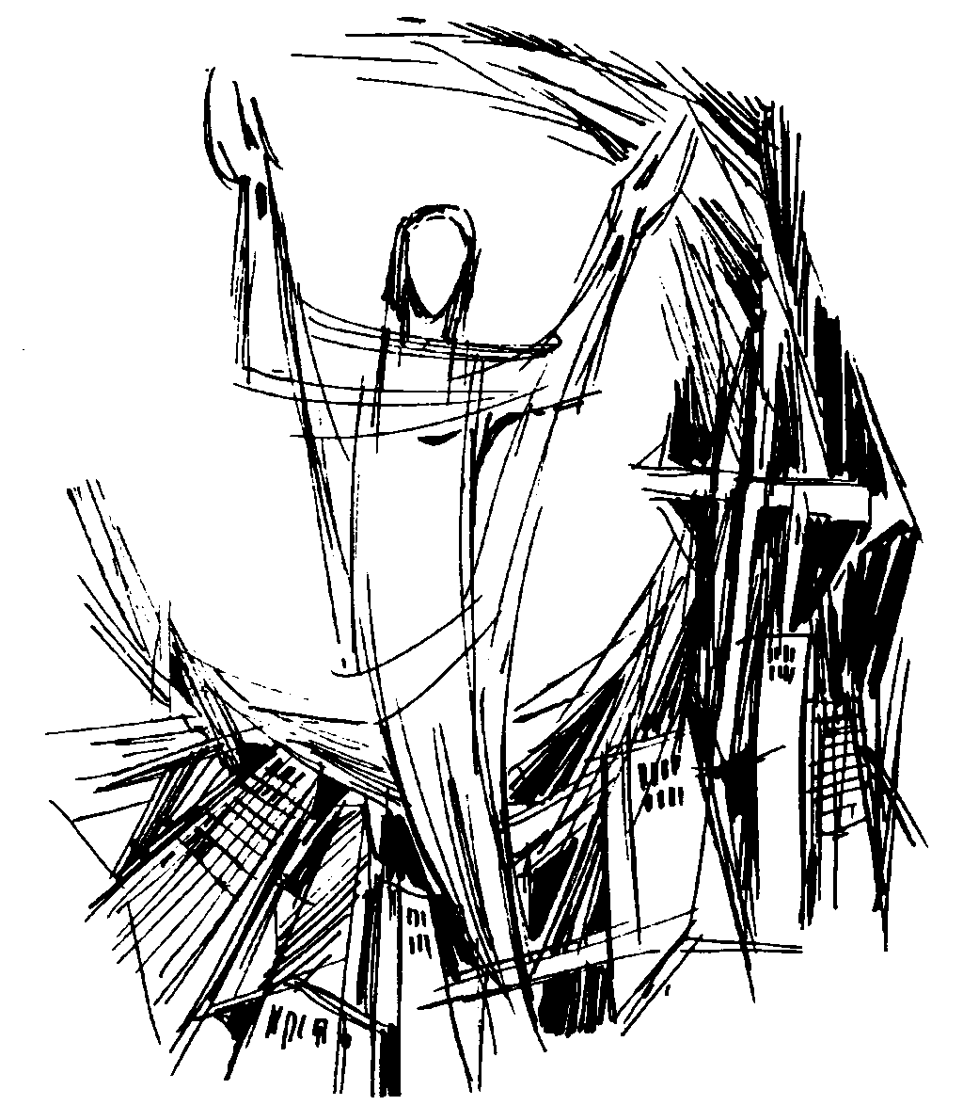

Good Shepherd with St. Peter’s

**A Service Booklet**

for the Easter Season

*All the words you need for this service are in this booklet. Please join in the parts in bold. The service leader will invite you to stand and sit.*

**Welcome**

*The service begins with a welcome from the service leader*

**The Greeting**

The Lord be with you

**and also with you.**

Alleluia. Christ is risen!

**He is risen indeed. Alleluia!**

*An opening hymn is sung here*

**Prayer of Preparation**

**Almighty God,**

**to whom all hearts are open,**

**all desires known,**

**and from whom no secrets are hidden:**

**cleanse the thoughts of our hearts by the inspiration of your Holy Spirit,**

**that we may perfectly love you, and worthily magnify your holy name;**

**through Christ our Lord.**

**Amen.**

**Confession**

In baptism we died with Christ, so that as Christ was raised from the dead, we might walk in newness of life. Let us receive new life in him as we confess our sins in penitence and faith.

We have lived by our own strength, and not by the power of your resurrection.

In your mercy, forgive us.

**Lord, hear us and help us.**

We have lived by the light of our own eyes, as faithless and not believing.

In your mercy, forgive us.

**Lord, hear us and help us.**

We have lived for this world alone, and doubted our home in heaven.

In your mercy, forgive us.

**Lord, hear us and help us**

May the God of love and power

forgive us and free us from our sins, heal and strengthen us by his Spirit, and raise us to new life

in Christ our Lord.

**Amen.**

**Gloria in Excelsis**

*The words of the Gloria may be said or sung. An alternative version of the Gloria may be used on occasion.*

**Glory to God in the highest,**

**and peace to his people on earth.**

**Lord God, heavenly King,**

**almighty God and Father,**

**we worship you,**

**we give you thanks,**

**we praise you for your glory.**

**Lord Jesus Christ,**

**only Son of the Father,**

**Lord God, Lamb of God,**

**you take away the sin of the world: have mercy on us;**

**you are seated at the right hand of the Father:**

**receive our prayer.**

**For you alone are the Holy One, you alone are the Lord,**

**you alone are the Most High, Jesus Christ,**

**with the Holy Spirit,**

**in the glory of God the Father. Amen.**

*The Collect (prayer for the day) is usually said here.*

*The children may leave the service at this point to go to their own activities. The service leader will tell*

*people where to go, and when the children will return.*

**Bible Reading**

*At the end the reader will say:*

This is the word of the Lord.

**Thanks be to God.**

*A hymn is usually sung here*

**Gospel Reading**

*When the Gospel reading is announced the reader will say:*

Alleluia, alleluia.

Jesus said, ‘I am the resurrection and the life. Those who believe in me, even though they die, will live, and everyone who lives and believes in me will never die.’

**Alleluia.**

Hear the Gospel of our Lord Jesus Christ according to *N.*

**Glory to you, O Lord.**

*At the end the reader will say:*

This is the Gospel of the Lord.

**Praise to you O Christ.**

**Sermon**

*After the sermon there may be opportunity for quiet reflection.*

**Creed**

Let us declare our faith in the resurrection of our Lord Jesus Christ.

**Christ died for our sins**

**in accordance with the Scriptures;**

**he was buried;**

**he was raised to life on the third day in accordance with the Scriptures;**

**afterwards he appeared to his followers,**

**and to all the apostles:**

**this we have received,**

**and this we believe.**

**Amen.**

**Prayers of Intercession**

*At the end of the prayers, please join in with these words:*

Merciful Father,

**accept these prayers**

**for the sake of your Son,**

**our Saviour Jesus Christ.**

**Amen.**

**The Peace**

The risen Christ came and stood among his disciples and said, ‘Peace be with you’. Then they were glad when they saw the Lord. Alleluia.

The peace of the Lord

be always with you

**and also with you.**

*We greet one another, and offer one another a sign of peace.*

*A hymn is usually sung here. During this hymn an offering is taken for those who wish to give to the work of the church.*

*On the first Sunday of the month there is the opportunity to receive prayer for healing after Communion. This takes place in the prayer corner on the left hand side at the front.*

*On the first Sunday of the month the children stay in their groups until the end of the service. On the third Sunday of the month the children return to take part in Communion.*

*If you have children in the ‘Early Years’ group you will need to collect them.*

**The Eucharistic Prayer**

The Lord is here.

**His Spirit is with us.**

Lift up your hearts.

**We lift them to the Lord.**

Let us give thanks to the Lord our God.

**It is right to give thanks and praise.**

It is indeed right, it is our duty and our joy, at all times and in all places to give you thanks and praise, holy Father, heavenly King, almighty and eternal God,

through Jesus Christ your Son our Lord.

For he is your living Word;

through him you have created all things from the beginning, and formed us in your own image.

**To you be glory and praise for ever.**

Through him you have freed us from the slavery of sin, giving him to be born of a woman and to die upon the cross; you raised him from the dead and exalted him to your right hand on high.

**To you be glory and praise for ever.**

Through him you have sent upon us your holy and life-giving Spirit,

and made us a people for your own possession.

**To you be glory and praise for ever.**

And now we give you thanks because in his victory over the grave a new age has dawned, the long reign of sin is ended, a broken world is being renewed and humanity is once again made whole.

Therefore with angels and archangels, and with all the company of heaven, we proclaim your great and glorious name, for ever praising you and *saying*:

**Holy, holy, holy Lord,**

**God of power and might,**

**heaven and earth are full of your glory.**

**Hosanna in the highest.**

**Blessed is he who comes in the name of the Lord.**

**Hosanna in the highest.**

Accept our praises, heavenly Father, through your Son our Saviour Jesus Christ, and as we follow his example and obey his command, grant that by the power of your Holy Spirit these

gifts of bread and wine may be to us his body and his blood;

who, in the same night that he was betrayed, took bread and gave you thanks; he broke it and gave it to his disciples, saying:

Take, eat; this is my body which is given for you; do this in remembrance of me.

**To you be glory and praise for ever.**

In the same way, after supper

he took the cup and gave you thanks; he gave it to them, saying:

Drink this, all of you; this is my blood of the new covenant, which is shed for you and for many for the forgiveness of sins.

Do this, as often as you drink it,

in remembrance of me.

**To you be glory and praise for ever.**

Therefore, heavenly Father, we remember his offering of himself

made once for all upon the cross; we proclaim his mighty resurrection and glorious ascension; we look for the coming of your kingdom, and with this bread and this cup we

make the memorial of Christ your Son our Lord.

**Lord, by your cross and resurrection you have set us free. You are the Saviour of the world.**

Accept through him, our great high priest, this our sacrifice of thanks and praise, and as we eat and drink these holy gifts in the presence of your divine majesty,

renew us by your Spirit, inspire us with your love and unite us in the body of your Son, Jesus Christ our Lord.

**To you be glory and praise for ever.**

Through him, and with him, and in him, in the unity of the Holy Spirit, with all who stand before you in earth and heaven, we worship you, Father almighty, in songs of everlasting praise:

**Blessing and honour and glory and power be yours for ever and ever.**

**Amen.**

**Lord’s Prayer**

As our Saviour taught us,

so we pray:

**Our Father in heaven,**

**hallowed be Your name,**

**Your kingdom come,**

**Your will be done,**

**on earth as in heaven.**

**Give us today**

**our daily bread.**

**Forgive us our sins**

**as we forgive those**

**who sin against us.**

**Lead us not into temptation,**

**but deliver us from evil.**

**For the kingdom, the power,**

**and the glory are Yours**

**now and for ever.**

**Amen**

**Breaking of the Bread**

Every time we eat this bread

and drink this cup

**we proclaim the Lord’s death until he comes.**

*The following response may be sung:*

**Lamb of God,**

**you take away the sin of the world, have mercy on us.**

**Lamb of God,**

**you take away the sin of the world, have mercy on us.**

**Lamb of God,**

**you take away the sin of the world, grant us peace.**

Alleluia. Christ our passover is sacrificed for us.

**Therefore let us keep the feast. Alleluia.**

*Communion is shared. You will be invited to come forward to receive.*

**Prayer after communion**

**God of truth,**

**we have seen with our eyes**

**and touched with our hands the bread of life:**

**strengthen our faith**

**that we may grow in love**

**for you and for each other;**

**through Jesus Christ our Lord.**

**Amen.**

*News and notices are shared. You can find out more about what’s going on by picking up our monthly notice sheet, or visiting our website: www.goodpeter.org.uk*

*A final hymn will be sung*

**Blessing**

May Christ,

who out of defeat brings new hope and a new future,

fill you with his new life;

and the blessing of

God Almighty,

the Father, the Son,

and the Holy Spirit,

be among you

and remain with you always.

**Amen**

He is not here, he is risen.

Go in peace to love and serve the Lord. Alleluia, alleluia.

**In the name of Christ. Amen. Alleluia, alleluia.**

*You’re warmly invited to stay for tea and coffee after the service*

This service is taken from Common Worship: Services and Prayers for the Church of England. Copyright acknowledgement: Some material included in this service is copyright: © The Archbishops' Council 2000. Kyrie Eleison © The Archbishops' Council 2002